April 19th 2026 to April 25th 2026
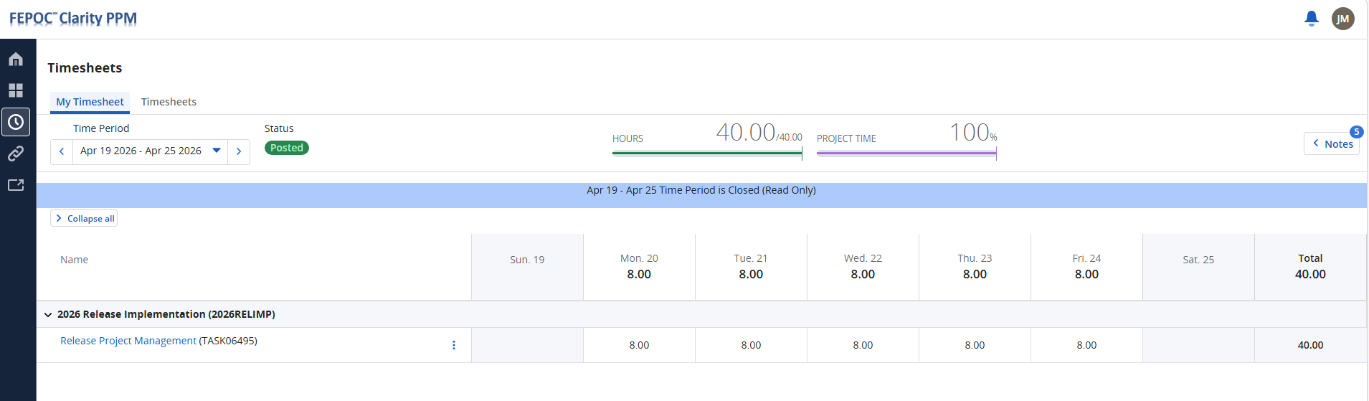

April 26th 2026 to April 30th 2026
